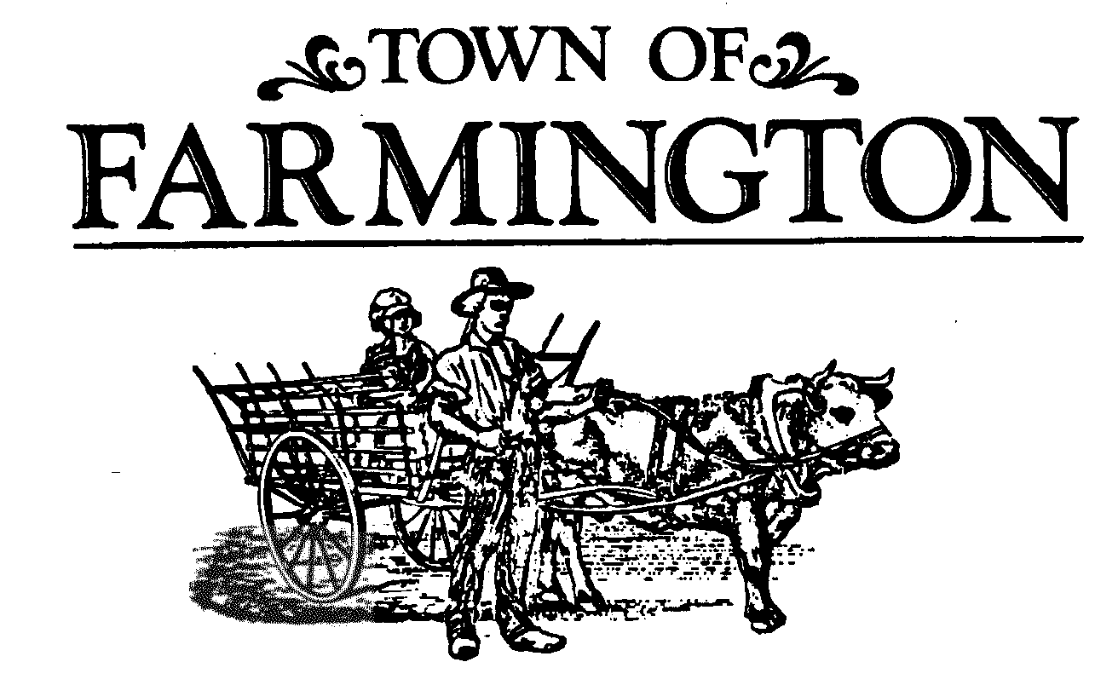
“New” Dog License Application ONLY
(must renew licenses every year)

Please fill out the following information and mail:
- The application form filled out
- Proof of Rabies Vaccination (showing date given and expiration date)
- Spay/Neuter Certificate (if applicable)
- *Payment (checks made payable to ‘Town of Farmington’) see amount below.

Owner Information

Name:_________________________________________

Physical Address: ________________________________________

_________________________________________
(If Mailing address is different, please provide both)

Phone Number: _________________________________________

Email: _________________________________________

Dog Information

Name: ______________________________________

Breed: ______________________________________

Color: _______________________________________

Year of Birth: _________________________________

Sex: ________________________________________

◻ $20.00 Spay/Neuter Dog ◻ $30.00 Non Spay/Neuter Dog

Senior Resident (age 60 or older) Rates:
◻ $12.00 Senior Spay/Neuter Dog ◻ $22.00 Senior Non Spay/Neuter Dog

Please mail all paperwork and payment to:
Town Clerks Office
1000 County Rd 8
Farmington, NY 14425
(315) 986-8100 Option #1

